Criterion B: Design

Science Laboratory Inventory

**Menu of the Main Interface:**

It is the menu options to start with the recording of the equipment or to ordering equipment for the Science Laboratory.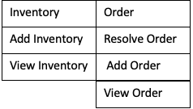

**Buttons of the Main Interface:**

|  |
| --- |
| Search |

**Submenus:**



**Class Diagram**

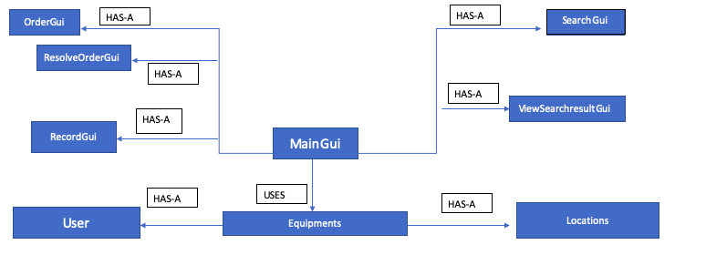

**Functions of the classes:**

**1.**   **MainGui**: It creates the main interface of the program and it is central to all the class functions.

Relationships: 1. **Has-A** OrderGui. 2. **Has-A** RecordGui. 3. **Has-A** SearchGui.

**2.** **Equipment**: It has all the methods to record the instruments, subjects, topic(unit) and its unit.

Relationships: 1. **Has-A** Locations. 2. **Has-A** User.

**3.** **Locations:** It contains methods and variables of locations such as Roomname and Drawerno.

**4.** **User:** It contains the name of the user who orders or records the equipment.

**5.** **SearchGui:** It is the interface where the user puts the information to find the needed instruments for the particular unit of a subject. Relationships: 1. **Has-A** Equipment

**6. SearchResultGui:** It is the interface where the user views the search result.

Relationships: 1. **Has-A** Equipment

**7.** **OrderGui:** It is the interface where the user puts the information to order the needed instruments for the particular unit of a subject.

Relationships: 1. **Has-A** Equipment

**8. ResolveOrderGui:** It is the interface where the user resolves the order and record it in the record file. Relationships: 1. **Has-A** Equipment

**9.** **RecordGui:** It is the interface where the user puts the information to record the needed instruments for the particle unit of a subject.

Relationships: 1. **Has-A** Equipment

**UML Diagram of classes**

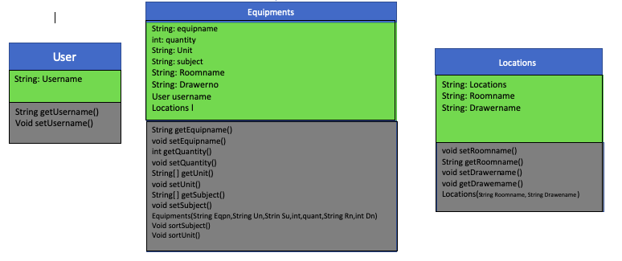

**GUI:**

1. **MainGui Interface:**

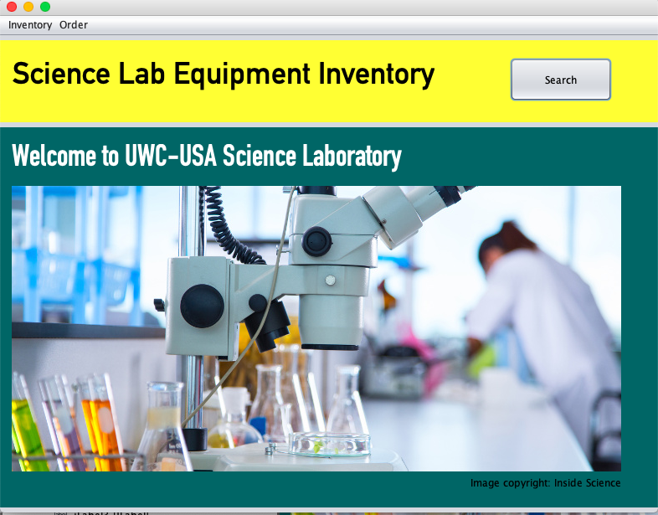

1. **Record Interface:**

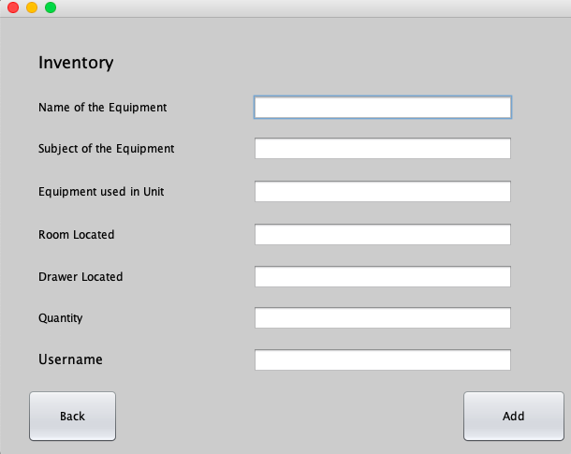

1. **ViewRecord Interface:**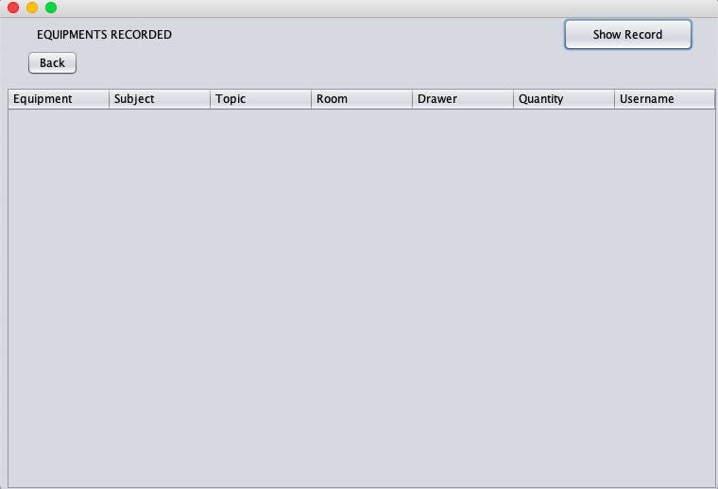
2. **SearchResult Interface:**

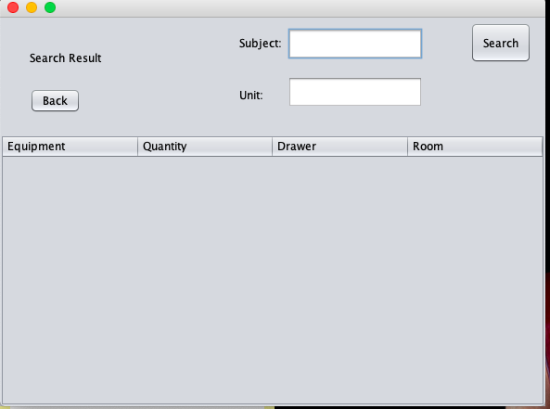

1. **Order Interface:**

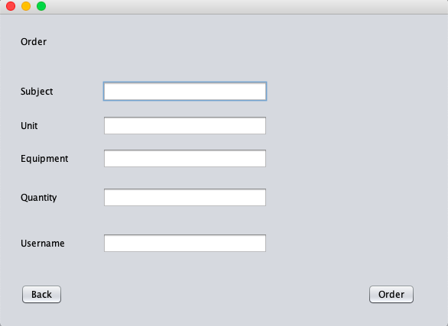

1. **View Order Interface:**

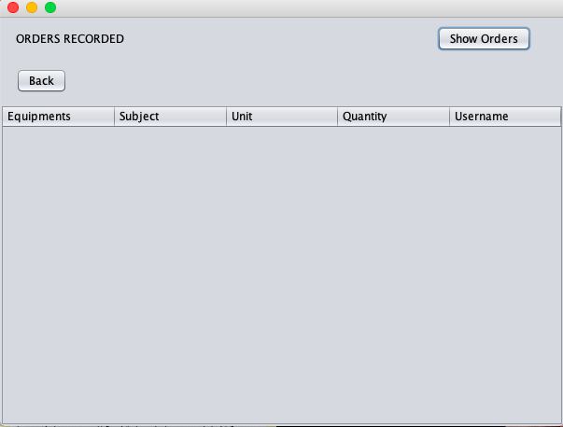

1. **Resolve Order Interface:**

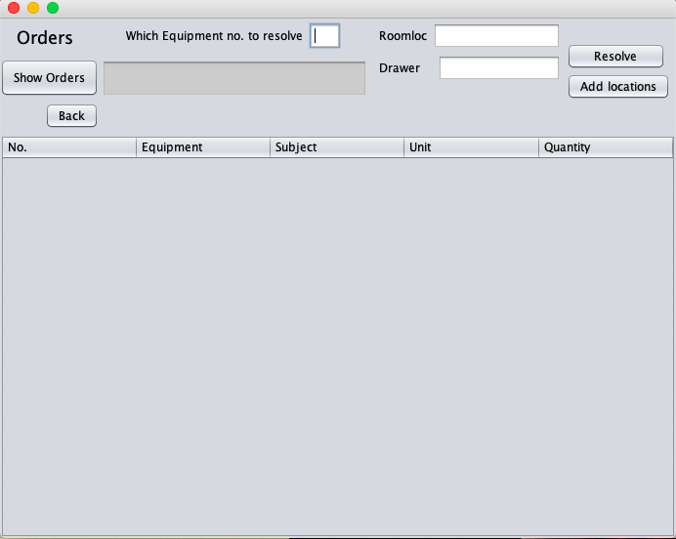

**System Flowchart:**

**1. Record Process:**

This process includes accepting input from the users and writes the record in the excel file in a sorted manner below respective columns of equipment name, name of the subject, topic, room location, drawer no, quantity and the user who recorded it.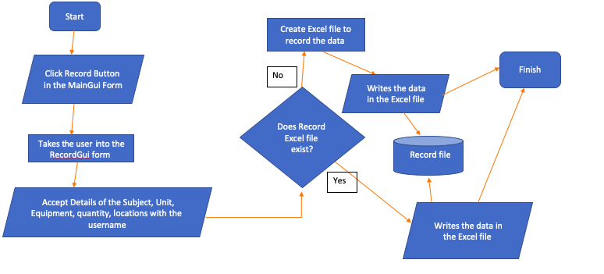

**2. Order Process:**

This process includes accepting input from the users and recorded in the excel file in a sorted manner below respective columns of equipment name, name of the subject, topic, quantity and the user who ordered it.

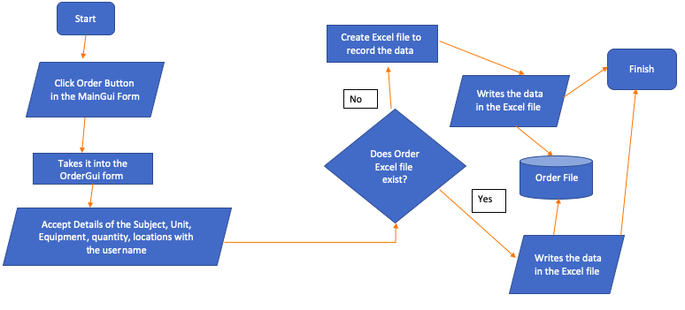

**3. Resolving Order Process:**

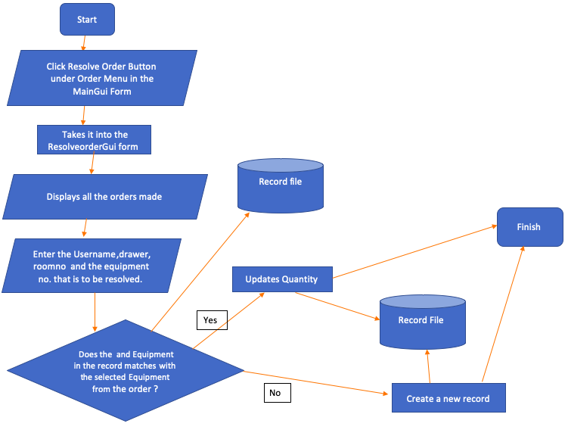

This process serves to check and sort the subjects, units, and equipment by its unique no. to resolve it by recording new equipment or to change the quantities if it has the same record in the record file.

**4. Search Process:**

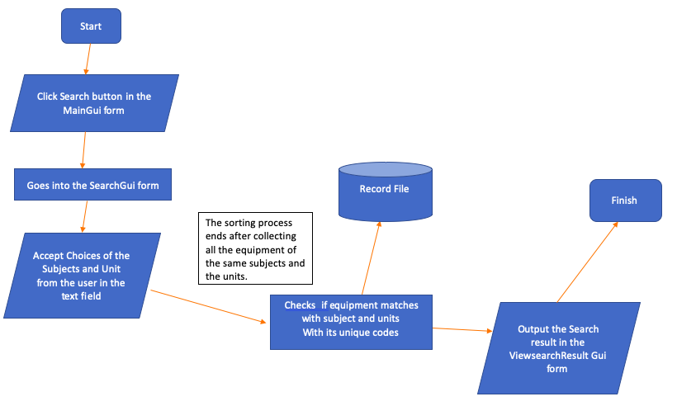

This process serves to sort equipment by its subjects and units to produce the search result of the list of equipment and the quantity.

**TEST PLAN:**

|  |  |
| --- | --- |
| **Actions to be tested** | **Test method** |
| Adding data in the record excel data | Add the equipment information through the RecordGui interface. Next, check if it is correctly or even recorded in the record excel file. |
| Adding data in the order excel data | Add the equipment information through the OrderGui interface. Next, check if it is correctly or even recorded in the order excel file. |
| Searching equipment based on the subject and topic from the record excel file | Input the subjects and topics where such equipment is needed. Choosing specific subjects and topics that already exist in the record excel file, check if it shows the type of equipment that is in the record excel file. |
| Resolving order and record it in the record excel file. The order resolved should be removed from the order excel file. The equipment if it is the same should only change the quantity in its existing record. Else, it should record the equipment in accordance with the information about the locations to be stored. | Select the order from the ResolveorderGui and input information about the locations to be stored. Press the resolve order button and then check the order excel file if it is removed and the record excel file if it is added into the record. |

Word Count: 366